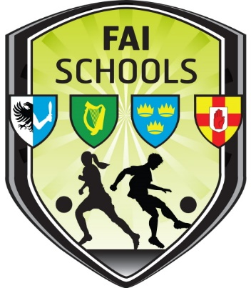

Girls Section: New League Format
The Leinster League will be divided into 8 Regional Leagues from 2019-20 onwards.
Medals will be awarded for regional league winners.
Within each Regional League the winner will progress to an 8 team Leinster Champions League Division One competition
The second placed team will progress to an 8 team Leinster League Cup Division Two.
The third placed regional league team will progress to the Leinster League Shield.
2019/2020 Regional Leagues
· Region 1 Wexford
· Region 2 East Wicklow, South Dublin
· Region 3 Carlow, Kilkenny, Laois
· Region 4 Westmeath, Longford, Offaly
· Region 5 Dublin Central
· Region 6 South West Dublin, West Wicklow, Kildare
· Region 7 West Dublin
· Region 8 North East; Meath, Louth, North County Dublin
Leagues of 8 teams or more, will be sub-grouped into Group A and B
Allocation to regional leagues will be at the discretion of the Girls Section Secretary.
At Champions League, League Cup and League Shield stages, an open draw will take place.

Therefore, if entering girls league competitions, please choose your preferred region.
Point Bonuses
A one-point bonus point will be awarded for all matches played to reward teams who engage with their fixtures in regional leagues.de

